**Brainstorming-Idea-Generation**

**TEAM ID-PNT2022TMID39459**

“It’s the easiest way to share your ideas, suggest changes, and let other team members rate and comment on these ideas. The comments and threaded chat keep the document clean and everything is automatically saved on the cloud,” Sadi says. “Once an idea is approved the document link can be shared with everybody working on the idea (writer, data analyst or designer) to give them an idea of the goals, concerns, and challenges associated with that idea. layers and much more.”

[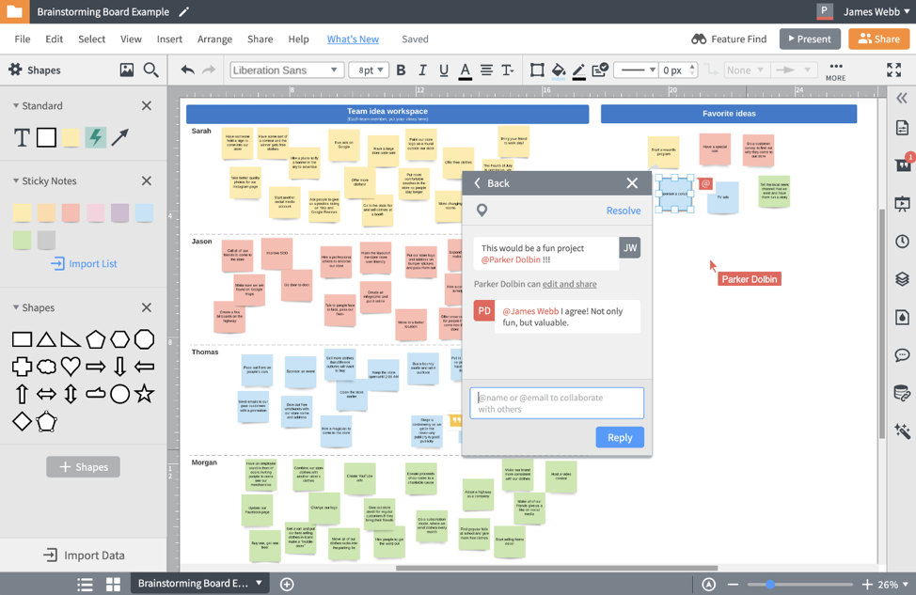](https://www.lucidchart.com/)

” [Michael Chammas](https://www.linkedin.com/in/michael-chammas/), CEO and founder of Makro Agency, says his team conducts all their remote brainstorming with the versatile virtual whiteboard: “It comes with a lot of pre-built templates as well as great features such as sticky notes. You can easily import images, PDF, PowerPoint files, keynotes, etc. When the session is over, you can easily export the entire board to share it with your team.” Anh Trinh, managing editor of GeekWithLaptop, says Miro integrates well with Slack and other instant messaging apps, allowing people to post their ideas anytime from anywhere.

[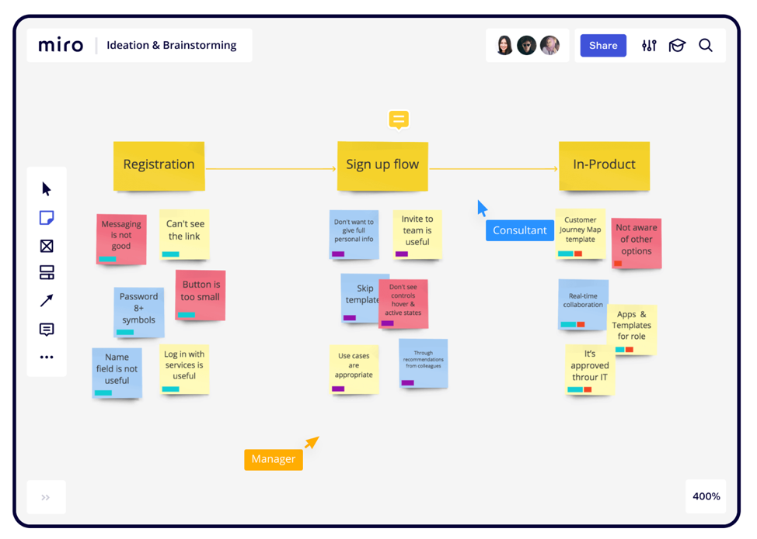](https://miro.com/)

Online brainstorm and collaboration tool [Mural](https://protect-us.mimecast.com/s/DHlbCmZ2Eot5A3QY7cG4Tvz?domain=mural.co/) has a digital dry-erase board that all members can contribute to. [Matt Zajechowski](https://twitter.com/MattZajechowski), outreach team lead at Digital Third Coast, says the tool’s sticky-note feature is especially useful for organizing lists, flowcharts, and diagrams that can help align a virtual brainstorm.

[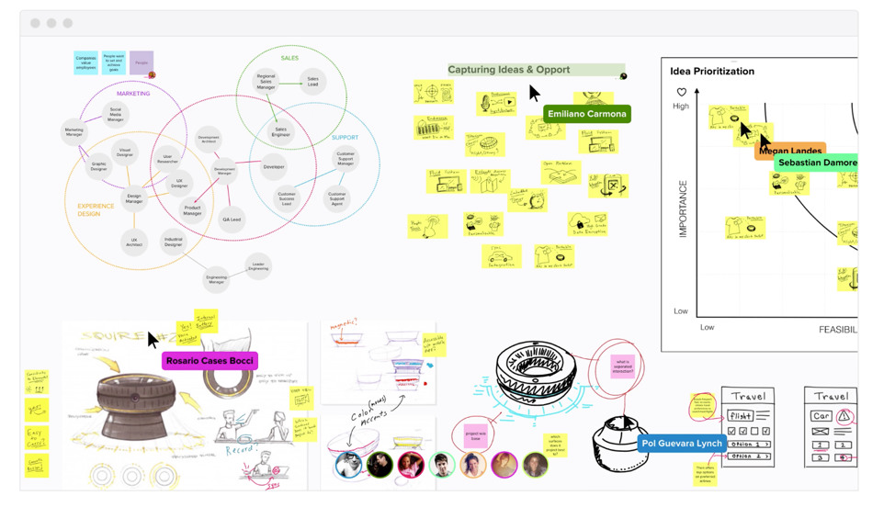](https://mural.co/)

“Our creative team went back a little to our old-school roots of sketching with pencil and paper to share ideas and get them across. Too often we rely on software as a crutch and jump right on the computer as opposed to using the computer as a tool. Our best design ideas tend to come from doodling or putting tight sketches together rather than getting lost down rabbit holes of software or design reference websites. After we have our sketch review, we scan our images into our design software and then render them into tight vector graphics.”